Answer 6
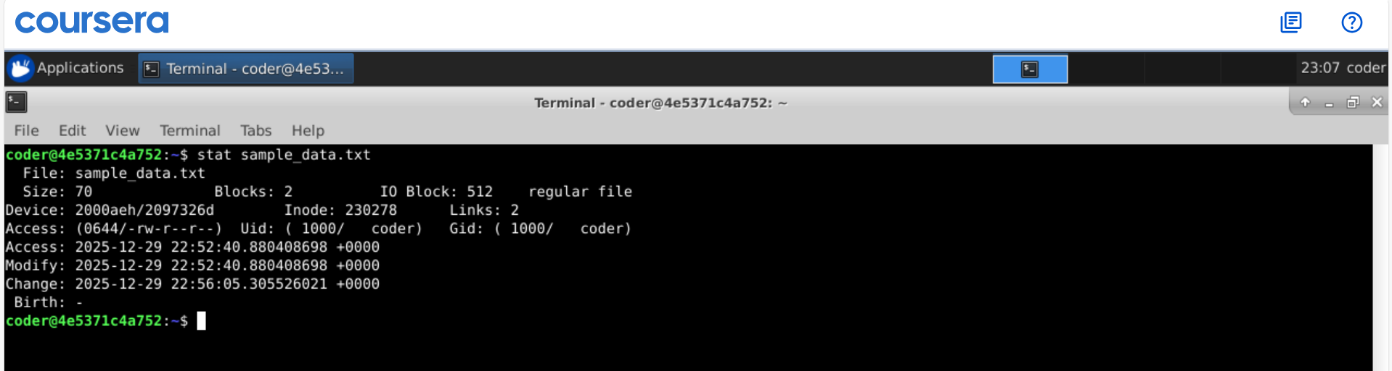
Explanation: Stat command followed by the file name gets us the all info about file with its creation date detailed file information (permissions, ownership, size, timestamps).

